

**FNDB020 Accounting**

**Student Workbook**

Lecture and Tutorial

**Week 5: Adjustments (Part 2)**

**Completing the Accounting Cycle**

**Updated March 2018**

**The Accounting Cycle: Learning about the Adjustment Process**

**Figure 5.0: The Accounting Cycle Illustrating the Adjustment Process**

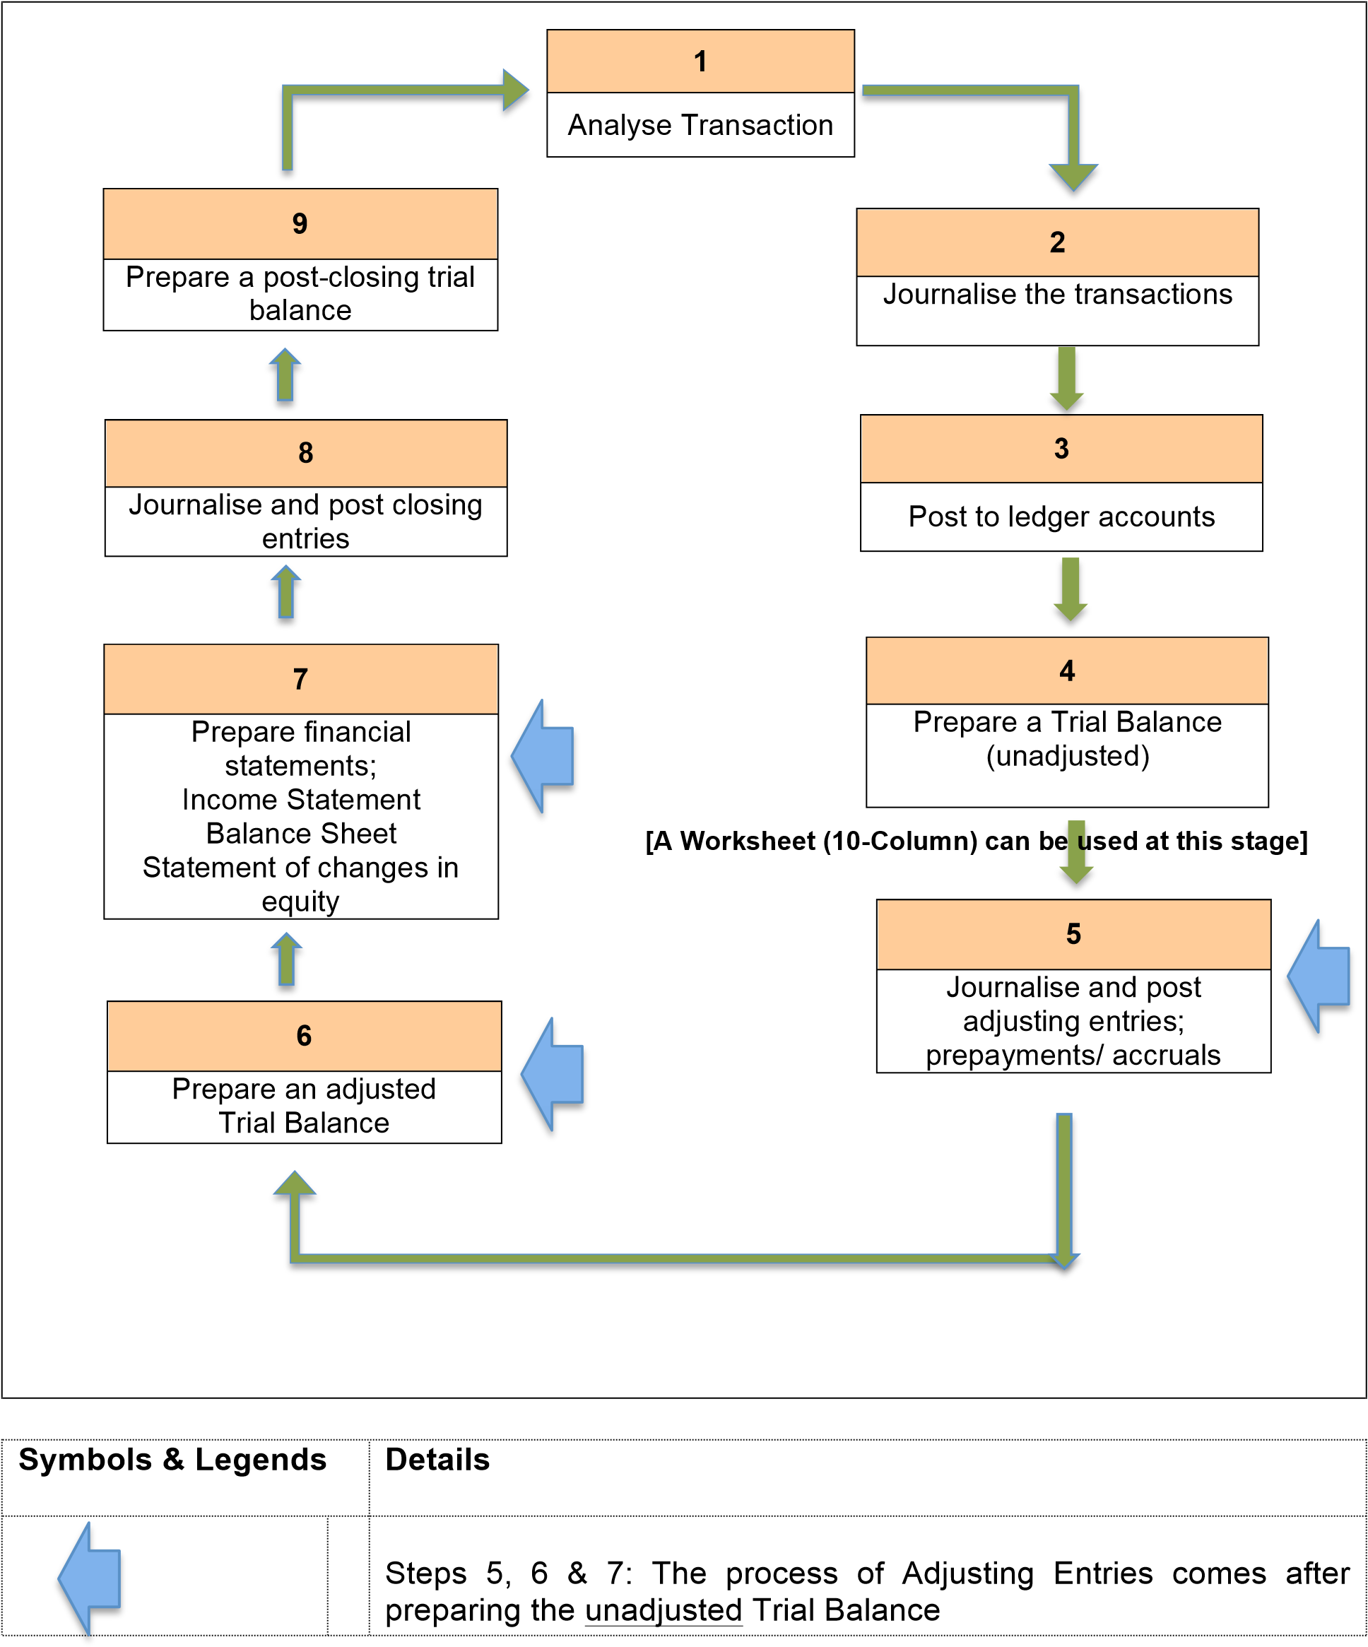

# FNDB020 Lecture Week 5: Adjusting Entries Revisited



ACCOUNTING FOR ADJUSTMENTS

**4**



a. Prepare unadjusted Trial

4

Balance of General Ledger



*5*

*.*

Prepare the Financial

Statements

Trial Balance

(

unadjusted)

Trial Balance

adjusted)

(



b. Determine adjusting

4

entries and/or



4

d. Prepare adjusted Trial

Balance of General Ledger



4

c.Post adjusting entries to

General Ledger

General Ledger

(

accounts adjusted)

4

Trial Balance -Unadjusted

**4**



**ADJUSTING: Using a**

**WORKSHEET**

## Revise Week 4 Adjusting entries can be classified as either prepayments or accruals:

Prepayments

1. Prepaid expenses: amounts paid in cash and recorded as assets until the economic benefits are used or consumed. It will then be expensed.
2. Prepaid Revenue: Cash advance received from customers. A liability is also recorded until the services are performed or the goods provided. It will then be recorded as income earned.

Accruals

1. Accrued revenues: amounts not yet received and not yet recorded for which the goods or services have been provided. It will be recorded as income earned but not received.
2. Accrued expenses: amounts not yet paid and not yet recorded for which the consumption of economic benefit has occurred. It will be recorded as an expense that has not been paid.

**Effects on the Financial Statement items if adjusting is not done:**

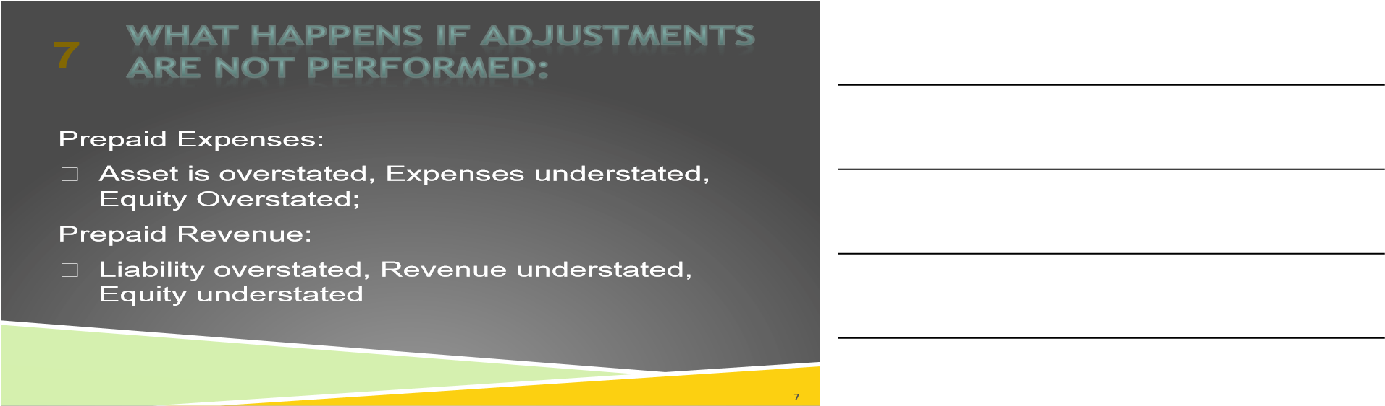

## Effects on Financial Statements if adjusting entries are not performed: Prepayments

* Prepaid Expenses: Asset is overstated,
* Expenses understated, (which means Owner’s Equity is Overstated)
* Prepaid Revenue: Liability overstated,
* Revenue understated, Equity understated

## **Prepaid Expenses:**

Prepaid Insurance for 1 year paid on 1st Jan (recorded as an asset with 12 months of future economic benefit) has expired over Jan, Feb, Mar, Apr, May Jun and must now be expensed on balance date 30 Jun 2018:

Record the entry on 1/1 and the required adjusting entry on 30/6 in the Gen Journal and General ledger

|  |  |  |  |
| --- | --- | --- | --- |
| Dr | Cash at Bank | | Cr |
|  |  |  |  |
|  |  |  |  |
|  |  |  |  |
|  |  |  |  |
| Dr | Prepaid Insurance | | Cr |
|  |  |  |  |
|  |  |  |  |
|  |  |  |  |
|  |  |  |  |
| Dr | Insurance expense | | Cr |
|  |  |  |  |
|  |  |  |  |
|  |  |  |  |
|  |  |  |  |
|  |  |  |  |

|  |  |  |  |
| --- | --- | --- | --- |
|  | General journal |  |  |
| Date | Account name | DR | Cr |
|  |  |  |  |
|  |  |  |  |
|  |  |  |  |
|  |  |  |  |
|  |  |  |  |
|  |  |  |  |
|  |  |  |  |
|  |  |  |  |
|  |  |  |  |
|  |  |  |  |
|  |  |  |  |
|  |  |  |  |

## Prepaid Revenue:

Received cash payment in advance for a promise to provide services in the future (liability until services is provided). Example: Adele was paid $6,000 in April to provide design services for the 3 months covering Apr, May & June.

Record the **April** the journal entry was:

Dr Cash at Bank (A+) $6,000

Cr Unearned Revenue (L+) $6,000

On balance date 30 June 2016, all three months design is recognised as Services Revenue. The liability Unearned Revenue will need to be adjusted.

|  |  |  |  |  |  |  |  |  |
| --- | --- | --- | --- | --- | --- | --- | --- | --- |
|  | General journal |  |  |  |  | General Ledger | |  |
| Date | Account name | DR | Cr |  | Dr |  | | Cr |
|  |  |  |  |  |  |  |  |  |
|  |  |  |  |  |  |  |  |  |
|  |  |  |  |  |  |  |  |  |
|  |  |  |  |  |  |  |  |  |
|  |  |  |  |  | Dr |  | | Cr |
|  |  |  |  |  |  |  |  |  |
|  |  |  |  |  |  |  |  |  |
|  |  |  |  |  |  |  |  |  |
|  |  |  |  |  |  |  |  |  |
|  |  |  |  |  | Dr |  | | Cr |
|  |  |  |  |  |  |  |  |  |
|  |  |  |  |  |  |  |  |  |
|  |  |  |  |  |  |  |  |  |

## Accruals:

Adjusting entries for accruals are required to record revenues and expenses for the accounting period that have **not been recognised** through daily entries. An adjusting entry for accruals will increase account balances in **both** the Balance Sheet and the Income Statement.

Effects on Financial Statements if adjusting entries are not performed: Accruals

* Accrued Expenses: Expenses & Liability understated, Equity overstated
* Accrued Revenue: Asset & Income understated, Equity understated

## Accrued Expenses:

Adele has not recorded that she owes (liabilities) wages of $600 to her part-time assistant for helping out in the business in the current accounting period (expenses).

|  |  |  |  |  |  |  |  |  |
| --- | --- | --- | --- | --- | --- | --- | --- | --- |
|  | General journal |  |  |  |  | General Ledger | |  |
| Date | Account name | DR | Cr |  | Dr |  | | Cr |
|  |  |  |  |  |  |  |  |  |
|  |  |  |  |  |  |  |  |  |
|  |  |  |  |  |  |  |  |  |
|  |  |  |  |  |  |  |  |  |
|  |  |  |  |  | Dr |  | | Cr |
|  |  |  |  |  |  |  |  |  |
|  |  |  |  |  |  |  |  |  |
|  |  |  |  |  |  |  |  |  |

## Accrued Revenue:

The Nursery owes Adele (accounts receivable) Commission of 5% of sales revenue (income) to Adele for introducing a client. It is worth $550.

|  |  |  |  |  |  |  |  |  |
| --- | --- | --- | --- | --- | --- | --- | --- | --- |
|  | General journal |  |  |  |  | General Ledger | |  |
| Date | Account name | DR | Cr |  | Dr |  | | Cr |
|  |  |  |  |  |  |  |  |  |
|  |  |  |  |  |  |  |  |  |
|  |  |  |  |  |  |  |  |  |
|  |  |  |  |  |  |  |  |  |
|  |  |  |  |  | Dr |  | | Cr |
|  |  |  |  |  |  |  |  |  |
|  |  |  |  |  |  |  |  |  |
|  |  |  |  |  |  |  |  |  |

## Adjusting Trial Balance

After adjusting entries are recorded in the general journal, they need to be posted to the ledger accounts so that an ***Adjusted Trial Balance*** can be prepared.

Financial statements are prepared from the adjusted trial balance.

Adjusted Trial Balance as at ???

|  |  |  |
| --- | --- | --- |
| Account name | DR | Cr |
|  |  |  |
|  |  |  |
|  |  |  |
|  |  |  |
|  |  |  |
|  |  |  |
|  |  |  |
| Total |  |  |

## Review task 1

Claire Lappin runs a manicure business. She has provided you with the following account balances for her business My Nails Rule as at 30 June, 2018.



The following balance day adjustments have NOT been completed:

* Salaries owing to staff - $600
* Supplies of nail polish unused at 30/6 was $2,500
* $1000 of the advertising Prepaid is for the next accounting period eg July 2018
* Depreciation on the office fittings - 20% on cost

*(Assume Depreciation for full year)*

Required:

1. Students could record the balance day adjustments in the **general journal** and post the entries to the ledger using the balances listed in the unadjusted trial balance.

Or

1. Correct the ledger accounts balances in the adjusted trial balance
2. Income Statement for 2018.
3. Balance sheet as at 30/6/2018.

General journal

|  |  |  |  |
| --- | --- | --- | --- |
| **date** |  | **dr** | **cr** |
|  |  |  |  |
|  |  |  |  |
|  |  |  |  |
|  |  |  |  |
|  |  |  |  |
|  |  |  |  |
|  |  |  |  |
|  |  |  |  |
|  |  |  |  |
|  | |  |  |

**Income Statement for year ended 30th June, 2018**

|  |  |  |
| --- | --- | --- |
|  | **$** | **$** |
|  |  |  |
|  |  |  |
|  |  |  |
|  |  |  |
|  |  |  |
|  |  |  |
|  |  |  |
|  |  |  |
|  |  |  |
|  |  |  |

Statement of Financial Position as at 30th June, 2018

|  |  |  |  |  |  |
| --- | --- | --- | --- | --- | --- |
| **Assets** | **$** | **$** | **Liabilities** | **$** | **$** |
|  |  |  |  |  |  |
|  |  |  |  |  |  |
|  |  |  |  |  |  |
|  |  |  |  |  |  |
|  |  |  |  |  |  |
|  |  |  |  |  |  |
|  |  |  |  |  |  |
|  |  |  | **Owners’ Equity** |  |  |
|  |  |  |  |  |  |
|  |  |  |  |  |  |
|  |  |  |  |  |  |

## Review Task 2

record the transaction in the General Journal

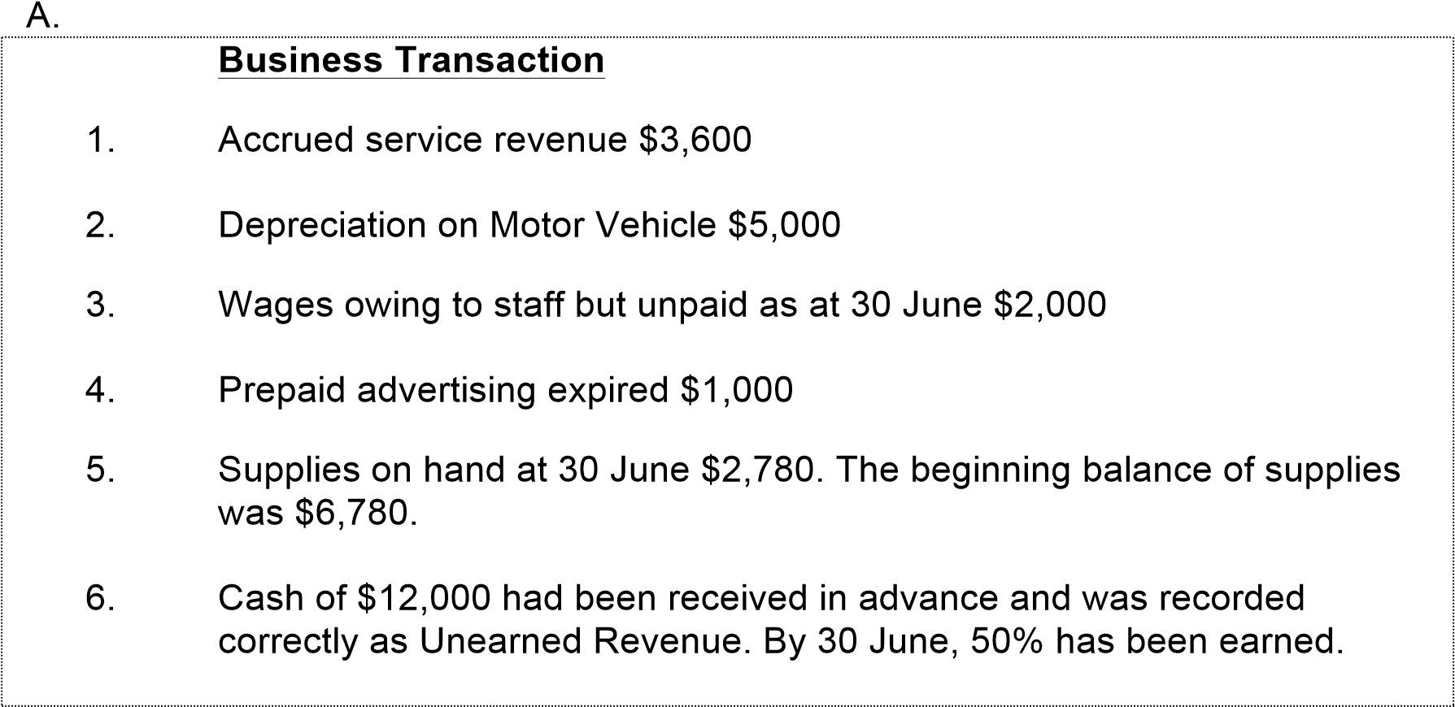

General Journal

|  |  |  |  |
| --- | --- | --- | --- |
| **Date** | **Account names** | **Dr** | **Cr** |
|  |  |  |  |
|  |  |  |  |
|  |  |  |  |
|  |  |  |  |
|  |  |  |  |
|  |  |  |  |
|  |  |  |  |
|  |  |  |  |
|  |  |  |  |
|  |  |  |  |
|  |  |  |  |
|  |  |  |  |
|  |  |  |  |
|  |  |  |  |
|  |  |  |  |
|  |  |  |  |
|  |  |  |  |

## Solution provided

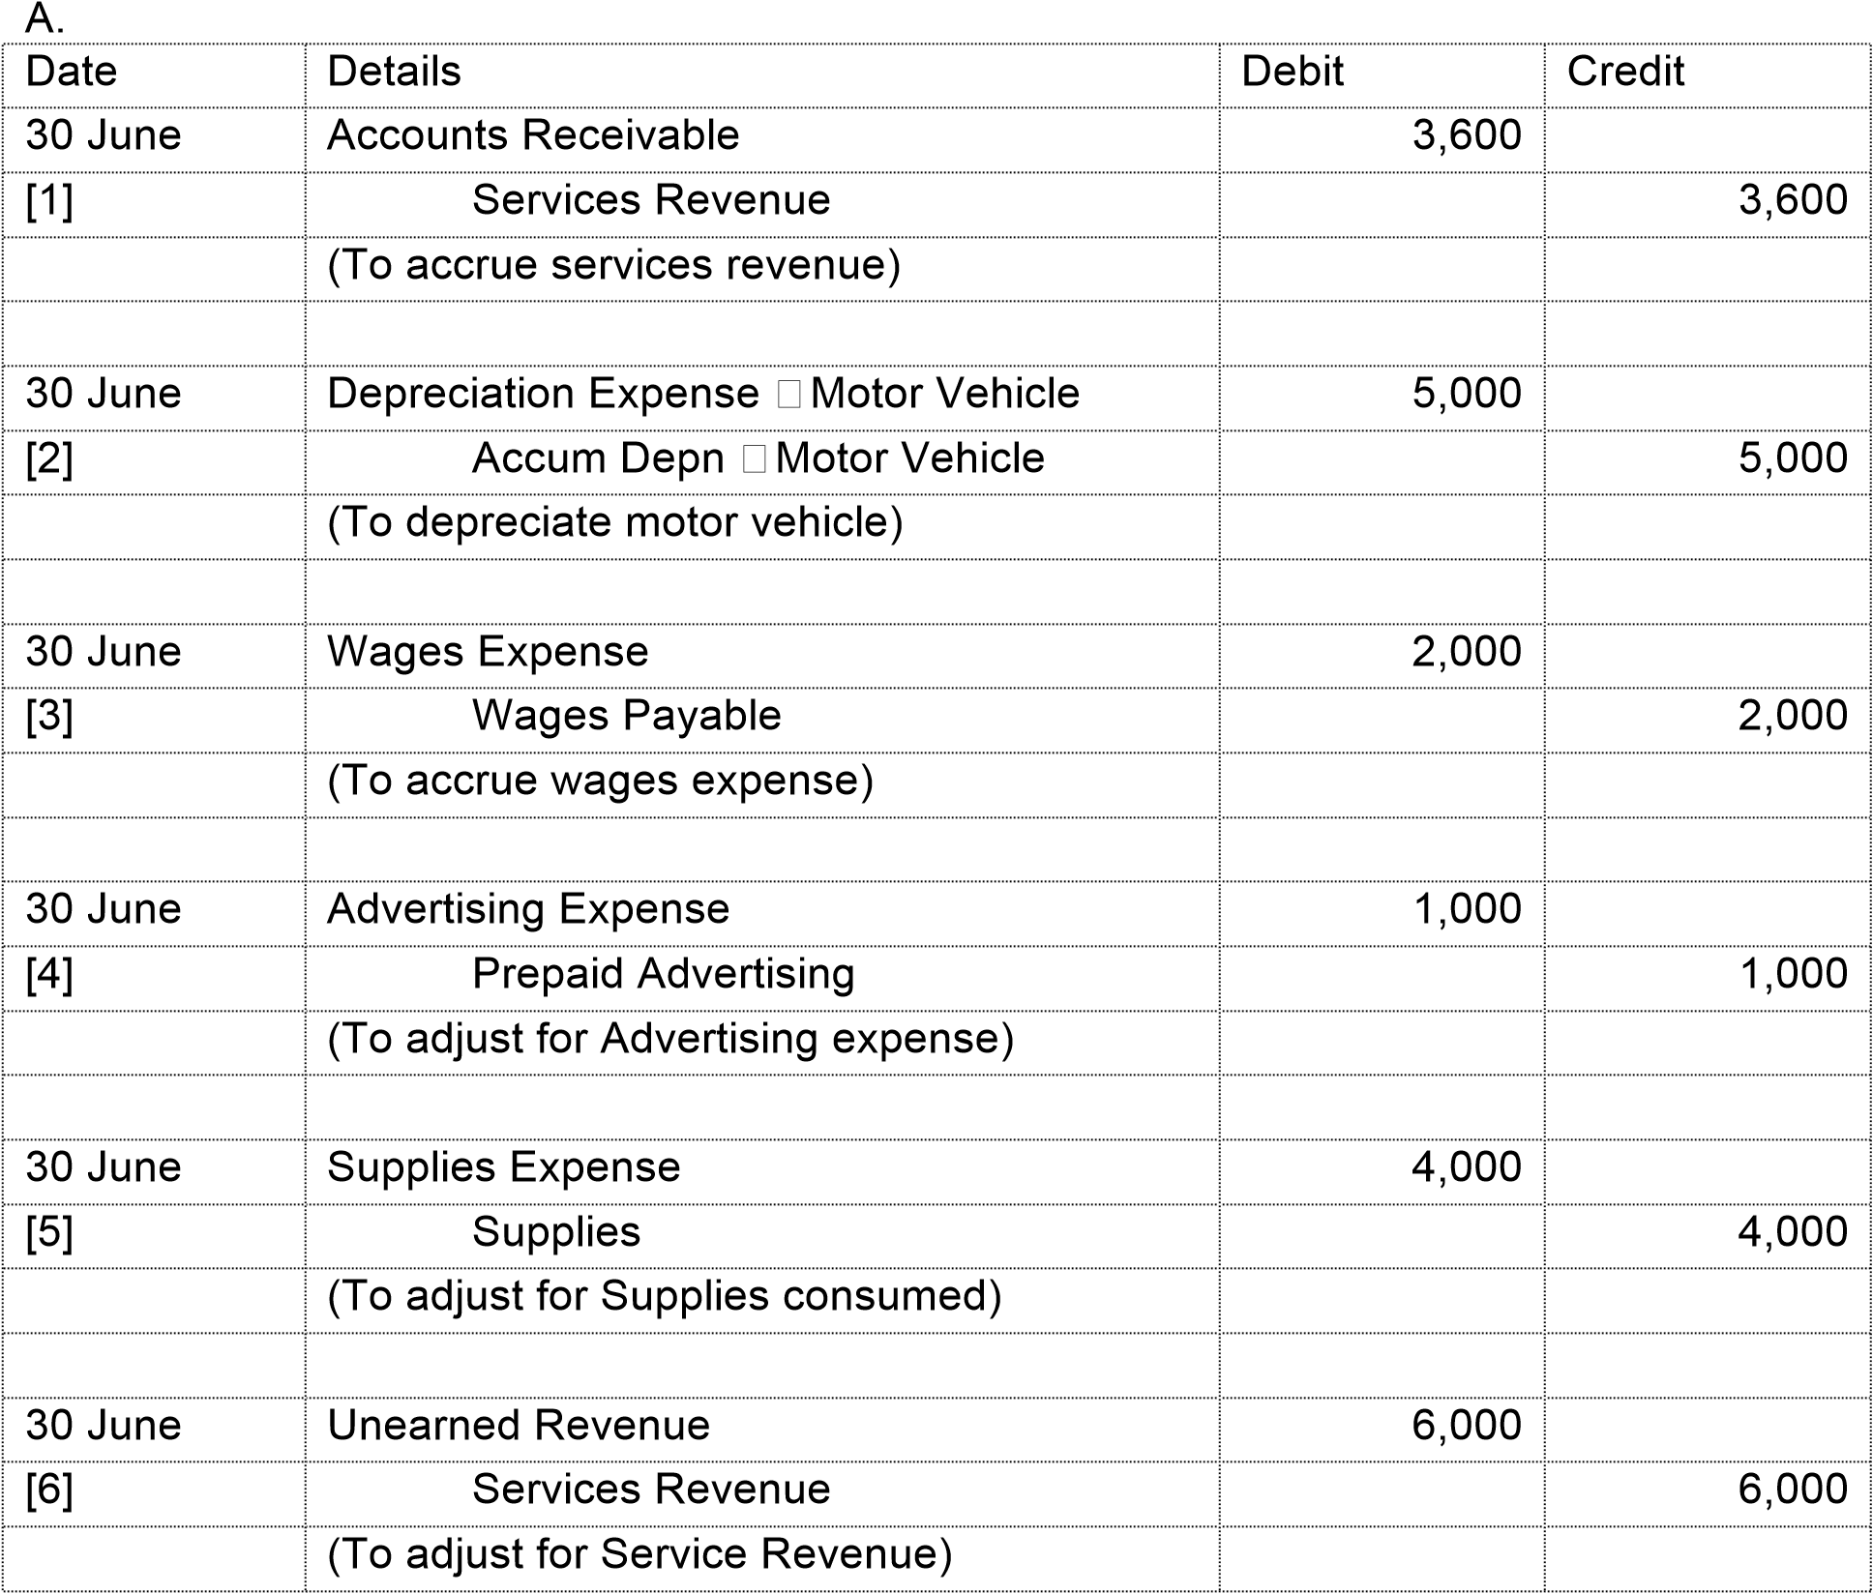

Adjusting Journal Entries on balance date 30 June 2018: (provided as reference)

## Closing the Books at the end of the Accounting Cycle

## Why close accounts?

The steps in the accounting cycle is performed in sequence and are repeated in each accounting period:

Steps 1 to 3: may occur daily during the accounting period.

Steps 4 to 7: are performed on a periodic basis, such as monthly, semi-annually (6-monthly) or annually. The Worksheet is used to record events to be *adjusted.*

**Steps 8 & 9**: closing entries and a post-closing trial balance, are usually only at the end of a business’s financial year.

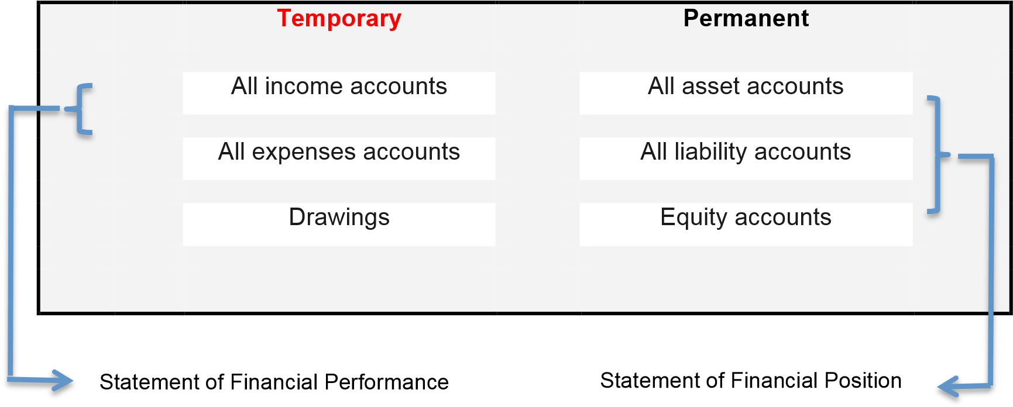

## Preparing Closing Entries: Illustration

To prepare for the *next* financial year, all income and expense accounts are ‘closed’ by transferring their end-of-year balance to a special ***temporary*** account, the *Profit & Loss Summary.* Closing or clearing reduces the balance in each account to ***zero*** and this helps prepare the accounts for the *next* accounting period.

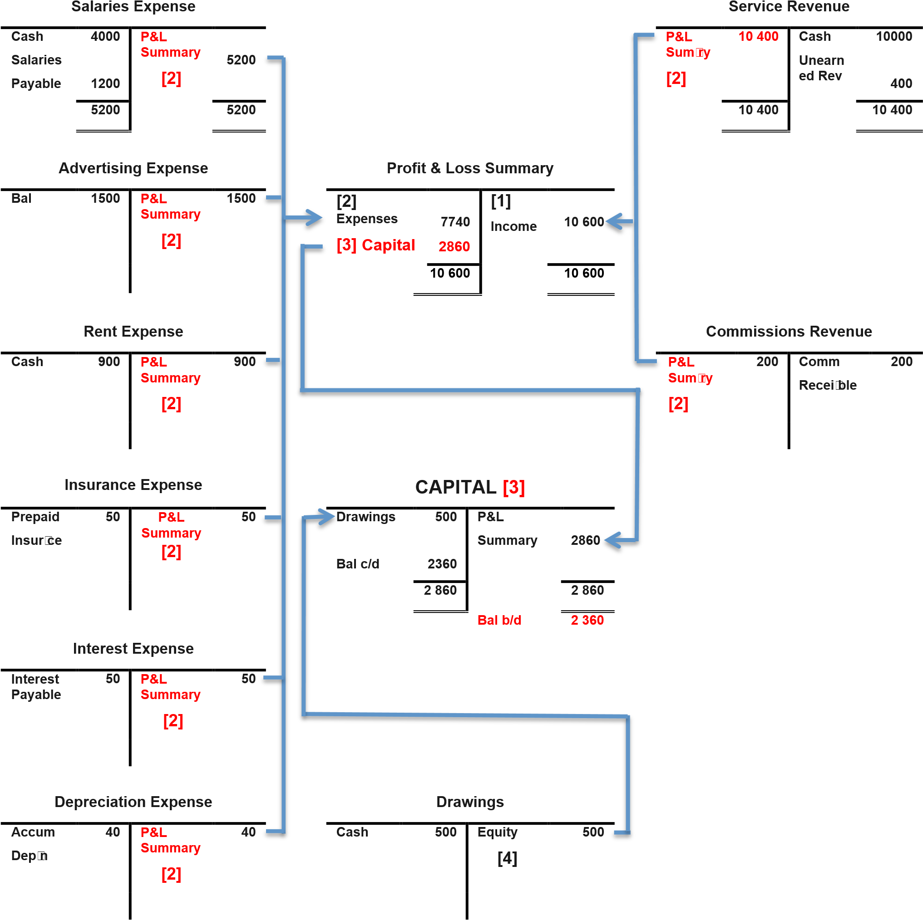

Closing entries journalized: (follow the trial provided above in Figure 5.2)

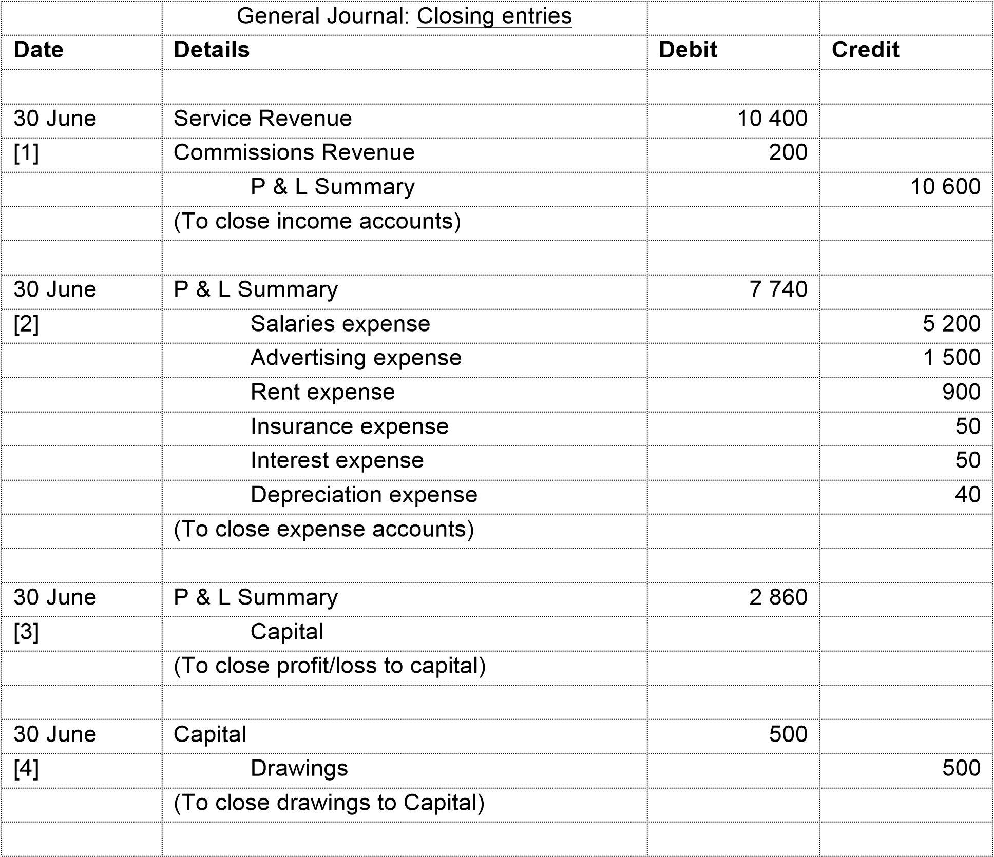

## Explain the purpose of closing entries:

One purpose of closing entries is to transfer the results of operations for the year to the

Profit & Loss Summary. Additionally it creates nil (zero) balances in all temporary accounts (income accounts, expense accounts and drawings), ready for the start of the next financial year. To accomplish this, all temporary accounts are closed at the end of the financial year. Separate entries are made to close income and expenses to the P&L Summary. Then the P&L Summary to Equity and, Drawings to Equity. Only the temporary accounts are closed.

## The Required Steps in the Accounting Cycle are:

* 1. analyse business transactions,
  2. journalise the transactions,
  3. post to ledger accounts,
  4. prepare an unadjusted trial balance,
  5. journalise and post adjusting entries,
  6. prepare an adjusted trial balance,
  7. prepare financial statements,
  8. journalise and post closing entries, and
  9. prepare a post-closing trial balance

* There are three Trial-Balances created in the Accounting cycle:

There are three Trial Balances along the Accounting Cycle - the unadjusted trial balance, the adjusted trial balance and the post-closing trial balance. Each have a specific purpose:

* + 1. Unadjusted Trial Balance provides a preliminary check on the accuracy of the posting process (debits and credits) from the journals to the ledger accounts.
    2. Adjusted Trial Balance prepared only at the end of the accounting period and includes the balances of all general ledger accounts after the adjusting entries have been posted to the accounts.
    3. Post Closing Trial Balance is prepared at the end of the accounting period after all closing entries have been posted to the accounts and the account balances determined.

## Nandini’s Spa: Post-closing journal, post-closing trial balance and Statement of Changes in Equity

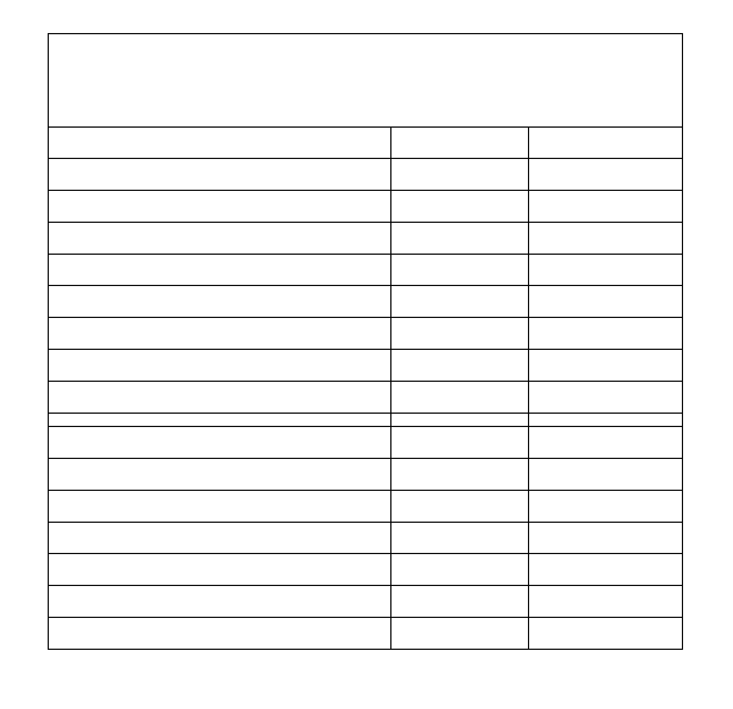

Nandini’s SPA

Adjusted Trial Balance

As at 30 June 201

7

**Debits**

**Credits**

Cash at Bank

36,000

Accounts

Receivable

15,400

Prepaid Rent

3,600

Furniture

82,400

Accum. Furniture

18,000

Accounts Payable

26,000

Wages Payable

2,280

Capital

86,800

DRAWINGS

12,000

Service Revenue

87,000

Advertising expense

22,280

Rent expense

17,400

Wages

expense

12,800

Depn expense Furniture

18,000

**219,880**

**219,880**



CURRENT ASSETS



NON

-

CURRENT

ASSETS



CURRENT

LIABILITY



EQUITY



TEMPORARY

ACCOUNTS:

Drawings

Income

Expenses



**Summary of the Closing Process**

**:**

1.

Close income accounts to the P&L

Summary account;

2.

Close expense accounts to the P&L Summary account;

3.

Close the P&L Summary account to the Capital account;

4.

Close Drawings account to the Capital account

***Required:***

Using the adjusted trial balance above, prepare the closing entries for Nandini’s Spa, a post closing balance at 30 June 2018 and a Statement of Changes in Equity.

|  |  |  |  |
| --- | --- | --- | --- |
| Date | Details | Debit | Credit |
|  |  |  |  |
|  |  |  |  |
|  |  |  |  |
|  |  |  |  |
|  |  |  |  |
|  |  |  |  |
|  |  |  |  |
|  |  |  |  |
|  |  |  |  |
|  |  |  |  |
|  |  |  |  |
|  |  |  |  |
|  |  |  |  |
|  |  |  |  |
|  |  |  |  |
|  |  |  |  |
|  |  |  |  |
|  |  |  |  |
|  |  |  |  |

|  |  |  |  |
| --- | --- | --- | --- |
| Nandini’s Spa  Post-Closing Trial Balance As at 30 June 2018 | |  |  |
|  |  | Debit | Credit |
|  |  |  |  |
|  |  |  |  |
|  |  |  |  |
|  |  |  |  |
|  |  |  |  |
|  |  |  |  |
|  |  |  |  |
|  |  |  |  |
|  |  |  |  |
|  |  |  |  |
|  |  |  |  |

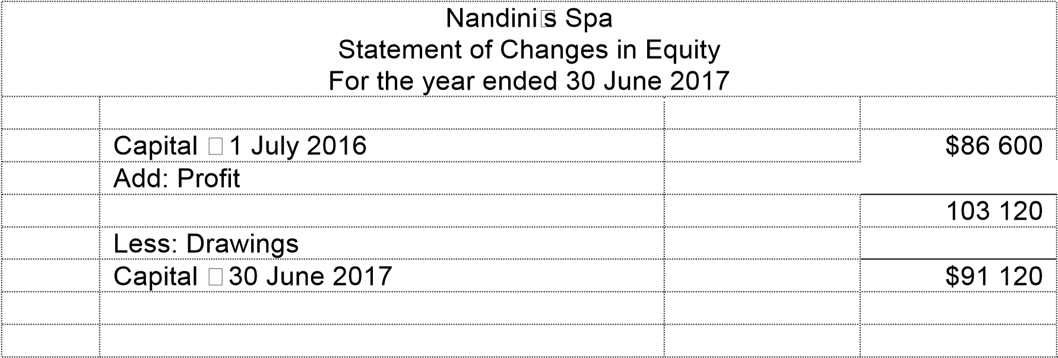

Tutorial Week 5 DISCUSSION QUESTION

**prepayments :** are expenses paid in advance or revenues received in advance (unearned revenue). They are referred to as ‘Prepayments’ in Lectures.

1. *During the year, the publishers of* Fishing for the Family*, a monthly magazine, received cash for a 3-year magazine subscription. A credit was made to the Unearned Subscriptions Revenue account.*

1. *Is the required adjusting entry made at the end of the period an example of accrual or a prepayment (deferral)?*
2. *What types of accounts will be affected by the required adjusting entry?*
3. *What effect will omission of the adjusting entry have on profit and on the statement of financial position?*

|  |
| --- |
| **Exercise 4.3** |

### Cash versus accrual accounting

1. *During March, Thuy Bui’s business performed services for a specific customer for which the fee was $9000. Payment was received in the following April.*

* 1. *Was the revenue earned in March or April?*
  2. *What account should be debited in (i) March and (ii) April?*

1. *During the month a business received $160 000 in cash and paid out $120 000 in cash. Does this indicate that the business earned $40 000 during the month? Explain.*

1. *Gorajek Sole Traders purchased a 3-year insurance contract on 1 March. The business debited the entire cost of $12 000 to Insurance Prepaid. The financial year ends on 30 June. Under the accrual system, what is the correct expense for the current year, and what entry would be made to correct the accounts? Under the cash basis of accounting, what is the correct expense and the correct adjusting entry (if any)?*

|  |
| --- |
| **Exercise 4.5** |

### Journalising adjusting entries

*Calvin’s Cleaning has employed you to investigate whether any accrual entries are needed in the business. On completion of your investigation on 30 June, you have discovered that the following items need attention:*

1. *Unearned cleaning services revenue now earned, $3200.*
2. *Depreciation not recorded, $12 000.*
3. *Employee salaries owed but not recorded, $6400.*
4. *Prepaid insurance expired, $1200.*
5. *Interest revenue accrued but not recorded, $1600.*

#### Required

1. *Prepare the adjusting entries for items 1 to 5 at 30 June, the end of the accounting period.*
2. *Suppose the adjusting entries in requirement A were not made. Calculate the total overstatement or understatement of profit as a result of the omission of these adjustments.*

A.

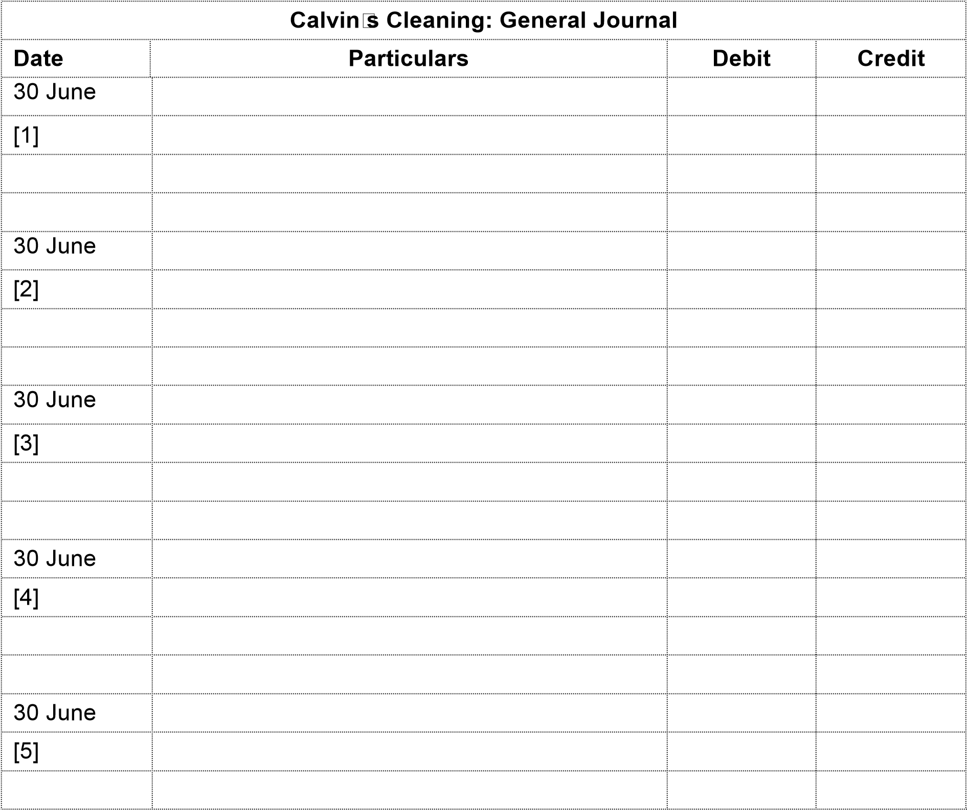

|  |
| --- |
| **Exercise 4.15** |

### Adjusting entries and effect on financial statements

*In the first column of the schedule presented below are the condensed financial statements for Melvin Motor vehicle Rentals before adjusting entries were made. The following items were not reflected in the statements:*

1. *Rental revenue earned but not collected or recorded, $1500.*
2. *Depreciation on vehicles not recorded, $14 500.*
3. *Wages earned by employees but not paid at year-end, $5600.*
4. *The company requires the first-day rental in advance as a deposit for making a reservation. The deposit is either deducted from the total rental charges or is forfeited. During the last week of June, deposits earned were not recorded as revenue, $990.*

1. *Prepare the necessary adjusting entries in general journal form.*

|  |  |  |  |
| --- | --- | --- | --- |
|  | **Melvin Motor Vehicle Rentals: General Journal** | |  |
| Date | Details | Debit | Credit |
|  |  |  |  |
|  |  |  |  |
|  |  |  |  |
|  |  |  |  |
|  |  |  |  |
|  |  |  |  |
|  |  |  |  |
|  |  |  |  |
|  |  |  |  |
|  |  |  |  |
|  |  |  |  |
|  |  |  |  |
|  |  |  |  |
|  |  |  |  |
|  |  |  |  |
|  |  |  |  |
|  |  |  |  |